**A PROPOSED OFFERING OF ONLINE PET ADOPTION FOR PAWSSION PROJECT**

A Thesis Project Presented to the Faculty of Datamex College of Saint Adeline, Inc.

**By:**

**Chavas, Mary Shelireen, D**

**INTRODUCTION**

The Online Pet Adoption System is an application that allows for animal shelters, current pet owners and those looking to adopt to connect via an online system to quickly view and adopt pets. The application serves as a vessel through which animals can be viewed, adoption requests can be generated and sent to either shelter/current owners and communication can be had all electronically without ever needing to meet in person.

**Brief Overview of the Project**

The project is to create an online application that does exactly what someone would do if they went to a shelter or a current pet owner's home and tried to adopt in personsomething that takes a lot of time and effort with necessarily red tape and geographical limitations. Therefore, by creating this application, one can search for pets based on species, breed, age, location available (as in rescue/shelter) and more. It can be accessed through any web browser and will help facilitate needs across the board.

**Background Information**

Without such an application, the means of pet adoption would remain reliant upon physical locations that may not always have time for the burgeoning pet adoption process. For instance, some persons who want to adopt may not have time nor the means to go to a shelter, yet they still want another companion animal. Shelters may not always have the means to keep their pets online; however, they may have dozens of pets for which additional exposure for adoption is necessary. They may even keep manual logs of who is interested in animals; however, this provides an easy way to see what's available versus what is wanted without losing slips of paper. Thus, an Online Pet Adoption System removes the geographical limitations of in-person/shelter adoptions and provides instantaneous access to compilations of materials.

**Objectives and Goals of the Project**

The goal of the Online Pet Adoption System is to make it quick and easy for people to find and adopt pets. It helps shelters and pet owners connect with adopters, keeps pet information accurate, and makes adoption requests simple to manage. The system also ensures that all data is safe and easy to access.

**CLIENT INFORMATION**

**Client Organization Overview**

Pawssion Project Foundation Inc. is a nonprofit animal welfare organization that works to rescue, rehabilitate, and rehome abused, neglected, and abandoned animals. Founded in [2018], the shelter has been a temporary home for animals in desperate need of rescue in San Jose del Monte, bulacan, specifically at 1429 Paradise 1, Purok 7, Tungkong Mangga. The shelter provides food, shelter, medical care, behavior correction, and most importantly a second chance at life.

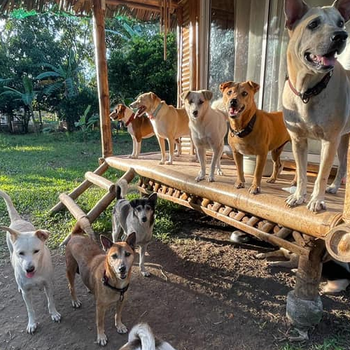

**Brief Description of the Client's Business and Industry**

The Online Pet Adoption System is a web-based service that provides an innovative and easier means for people to search for and adopt pets from shelters or rescue organizations. The Online Pet Adoption System will provide adopters with the ability to view pets available for adoption, submit an online application for adoption, and receive updates on the adoption of the pets, all online. The Online Pet Adoption system is designed to assist people, making pet adoption a more accessible, organized, and trusted process. The Online Pet Adoption system will be developed using the Agile software development approach. The Agile approach is to develop the application using multiple iterations (or versions), which will allow for ample testing and user input from adopters and shelter/shelter staff. The intent of using the Agile approach was to ensure that the system was useful, usable, and addressed a real need.

**PROJECT SCOPE**

**Description of Specific Deliverables and Outcomes**

This project is to develop a web-based application that will allow animal shelters, pet owners, and those looking to adopt pets to facilitate the pet adoption process. The final project outcome will involve a website for animal shelters, as well as private pet owners, to list their pets for adoption, an inventory of available animals that can be searched with detailed pet bios, a registration and login section for users, and the ability to create and check the status of a request to adopt a pet. An administrative backend will allow for user and pet inventory control. An online database will host all information, which will be accessible through any web browser to authenticated users.

Inclusions and exclusions what will be covered and what will not be covered by the project.

**Inclusion**

1. User registration and authentication for adopters, pet owners, and shelter staff
2. Ability for shelters and owners to create, edit, and remove pet listings with photos and descriptions
3. Submission and management of adoption requests.
4. Admin panel for managing users, pet listings, and adoption requests.
5. Secure online storage of all data.

**Exclusion**

1. The system will not include payment processing for adoption fees.
2. It will not provide real-time chat or messaging between users.
3. Mobile app development is not included; the system will be web-based only.
4. Integration with external animal databases or third-party services is not covered.
5. The system will not handle transportation or delivery of adopted pets

**Assumptions and constraints**

1. It is assumed that users have access to a device with an internet connection and a modern web browser.
2. Animal shelters and pet owners will provide accurate and up-to-completed within the timeline and budget date information about pets.
3. The system will be used only for legal and ethical pet adoption purposes.
4. The project must be agreed upon at the start of development.
5. The system’s performance may be limited by the hosting environment and internet connectivity.

**PROJECT APPROACH**

**Overview of the Proposed Approach**

The proposed approach to achieving the project goals will be to create the Online Pet Adoption System in a systematic, cohesive fashion. The project will involve assessing requirements and developing via testing and implementation before final release. Stakeholders will provide ongoing feedback so that all requirements and expected developments are met.

**Methodology and Framework**

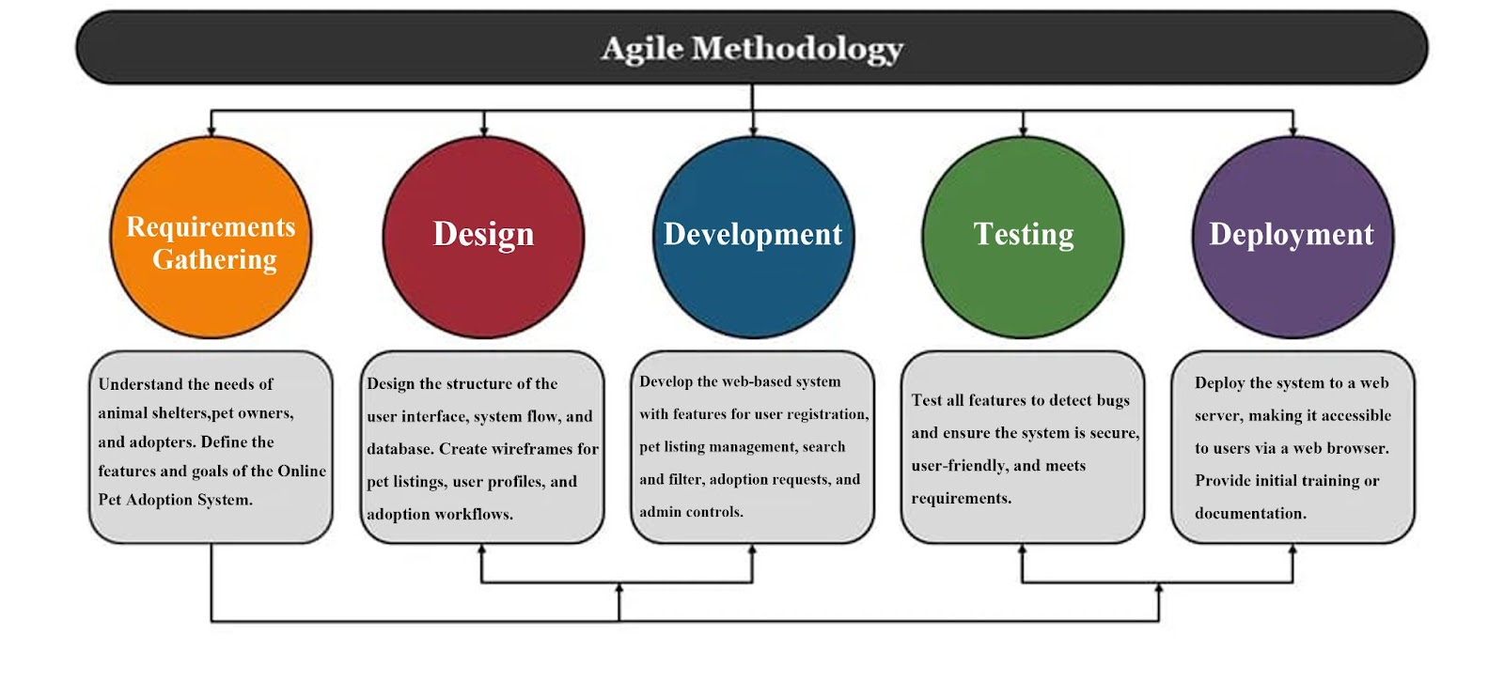The methodology to be used for this project is Agile. This is a commonly used methodology in software development as it provides an organized yet flexible structure that allows for adjustments in a collaborative environment. The framework involves an incremental process that emphasizes ongoing feedback and iteration, which is beneficial for this web application. The frameworks that may be used specifically include React or Angular.

**Key activities and milestones**

* **Requirements Gathering and Analysis:** Identify and document the needs of shelters, pet owners, and adopters.
* **System Design:** Create wireframes, database schema, and technical architecture for the platform.
* **Development:** Implement core features such as user registration, pet listings, search functionality, and adoption requests.
* **Testing:** Conduct thorough testing to ensure functionality, security, and usability.
* **Deployment:** Launch the system on a web server, making it accessible to users.
* **User Training and Support:** Provide documentation and support to help users navigate the system.

**Project Developer – Mary Shelireen Chavas**

**Brief Overview of Skills and Experience:**

I am the only person working on the Online Pet Adoption System. I will do everything for this project, including planning, designing, building, testing, and launching the website. I know how to make websites that are easy to use and safe. I can work with databases, create user logins, and build features that help people find and adopt pets. I will do my best to make a website that works well and is helpful for everyone.

**Project Timeline:**

This section provides a high-level weekly timeline for the Online Pet Adoption System project. The timeline covers the entire 3-month duration, dividing the project into clear and structured phases. Each week’s major activities and deliverables are outlined to ensure steady progress and successful completion of the system.

|  |  |  |
| --- | --- | --- |
| **Week** | **Phase** | **Activities/Deliverables** |
| 1-2 | Requirements Gathering | List features, set project goals, plan for users (shelters, adopters, admin), finalize requirements, gather feedback, and confirm project scope |
| 3-4 | Design | Plan website layout, user interface, database structure, create wireframes, finalize technical design |
| 5-6 | Preparation | Set up project environment, prepare tools and resources |
| 7-10 | Development | Build the web-based system: user registration, pet listings, search, adoption requests |
| 11 | Testing | Test all features, fix bugs, and ensure everything works well |
| 12 | Deployment | Launch the website, make it available to users |

**PROJECT RESOURCES**

This section outlines the main resources required for the successful planning, development, and implementation of the Online Pet Adoption System. It highlights the necessary tools, technology, and support needed at each stage of the project to ensure smooth progress and completion.

1. **HARDWARE**

* At least one computer or laptop for development, testing, and running the system.
* Reliable internet connection for accessing online tools and deploying the website.
* USB drive or external storage (optional, for backups).
* Web server or hosting service (for deploying the final system, if going live).

1. **SOFTWARE RESOURCES**

* Python (for running the web-based system).
* Flask and required Python libraries (for backend and web server).
* Web browser (such as Chrome, Firefox, or Edge) to access and test the system.
* SQLite (for the local database, included with Python).
* Code editor (Cursor).
* Bootstrap (for frontend UI design, included via CDN).

1. **Human Resources**

* Project Developer (responsible for all phases: planning, design, development, testing, deployment, and maintenance).

**Budget Allocation and Justification**

1. **HARDWARE**

* Computer/laptop: Provided by the developer (no extra cost if already available).
* USB drive or external storage: Optional, for backups (minimal cost).
* Web server/hosting: For deploying the website online (estimated cost: $3–$10 per month, depending on the provider).

1. **SOFTWARE**

* All required software and libraries are free and open-source, so there is no software cost.

1. **HUMAN RESOURCES**

* The project developer is a student working on the project as part of coursework, so no extra salary is needed.

1. **TOTAL BUDGET**

* The project can be completed with minimal cost, mainly for optional backup storage and web hosting, since all software is free and the developer already provides the necessary hardware.

**RISK MANAGEMENT**

Risk management for the Online Pet Adoption System focuses on identifying and addressing potential challenges such as technical issues, data security, time constraints, and user adoption. By planning for these risks, the project aims to ensure the system operates smoothly, securely, and meets the needs of all users.

**Identification of Potential Risks**

|  |  |  |
| --- | --- | --- |
| **Category** | **Details** | **Risk** |
| 1. **Technical Issues** | **Problems with website functionality, bugs, or compatibility issues across different browsers and devices.** | **System may not work as intended; users may encounter errors or poor experience.** |
| **b.) Time Constraints** | **Delays in completing project phases due to unforeseen challenges or underestimating the time required.** | **Project may not be finished on time or may miss important features.** |
| **c.) Data Security** | **Risk of unauthorized access to user or pet data.** | **Sensitive data could be exposed or misused, leading to privacy or legal issues.** |
| **d.) Limited Resources** | **Lack of access to certain tools, software, or hosting services.** | **Project progress may be slowed or blocked; may need to reduce features or quality.** |
| **d.) User Adoption** | **Difficulty in getting shelters, pet owners, or adopters to use the system.** | **System may not be used as intended, reducing its impact and value.** |
| **e.) Internet Connectivity** | **Dependence on a stable internet connection for development, deployment, and user access.** | **Users or developer may experience interruptions, affecting access and productivity.** |

**Mitigation Strategies**

|  |  |  |
| --- | --- | --- |
| **Identified Issue** | **Migration Strategy** | **Possible Impact if Not Addressed** |
| **Technical Issues** | Regular testing during development, using version control, and seeking help from online communities if needed. | System may face frequent errors, bugs, or crashes, leading to delays and reduced reliability. |
| **Time Constraints** | Create a detailed project schedule, set realistic deadlines, and prioritize essential features. | Project may be rushed, incomplete, or fail to meet deadlines, lowering overall quality. |
| Data Security | Use secure coding practices, implement userauthentication, and keep software up to date. | Risk of data breaches, unauthorized access, or loss of user trust. |
| Limited Resources | Use free or open-source tools whenever possible and plan for any necessary expenses in advance. | Project may face financial strain, limited functionality, or inability to scale. |
| User Adoption | Make the system user-friendly, provide clear instructions, and gather feedback for improvements. | Users may resist using the system, causing low engagement and wasted effort. |
| Internet Connectivity | Work offline when possible, during development and choose a reliable hosting provider for deployment. | Development may be disrupted, and system downtime may occur during deployment. |

**PROJECT GOVERNANCE**

**Governance Overview**

This project will be governed through clear planning, regular progress reviews, and careful decision-making at each stage. As the sole project developer, I am responsible for all decisions related to the design, development, testing, and deployment of the Online Pet Adoption System. I will set project goals, create schedules, and monitor progress to ensure the project stays on track.

**Decision Making Process**

Since I am working alone on this project, I will make all the important decisions myself. If there are big changes or problems, I will ask for advice from people who might use the system before deciding what to do.

**Roles and Responsibilities**

**Project Developer** (Mary Shelireen Chavas):

Responsible for all aspects of the project, including planning, design, coding, testing, deployment, and maintenance. Makes all key decisions and ensures the project meets its goals and deadlines.

Since this is a solo project, there are no other stakeholders involved. However, I will seek feedback from potential users and make improvements as needed to ensure the system is user friendly and effective

**School/Teacher (Stakeholder):** Gives feedback, helps test the system, and approves the final product